**CronosDoc Installation Guide.**

|  |
| --- |
| **Read this before Installation** |
| PHP Version: Preferred runtime is PHP version 5.3.4. Or use any PHP version that supports mysql_query, mysql_num_rows, mysql_fetch_assoc. |

**Installation Steps**

1. Copy the app folder to your website root (You can also install it in a folder).
2. Unzip the app.
3. Point your browser to your domain. I.e. [www.yourdomain.com/appfolder](http://www.yourdomain.com/appfolder). E.g. <http://naijadailywork.com/cronosdoc/>
4. Point your browser to [www.yourdomain.com/appfolder/install](http://www.yourdomain.com/appfolder/install). E.g <http://naijadailywork.com/cronosdoc/install> **IMPORTANT**
5. Fill the Installation form and Click on “install”.  
   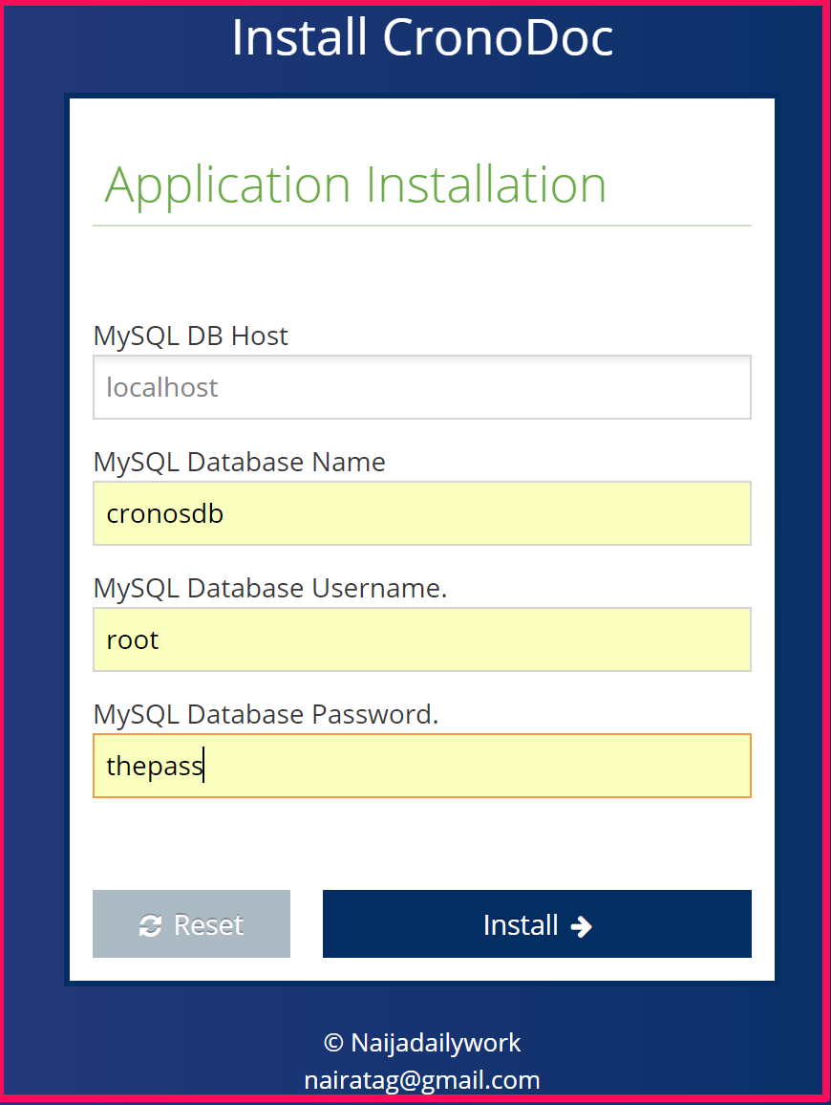
6. After a successful installation, you should see a success message as shown below.  
   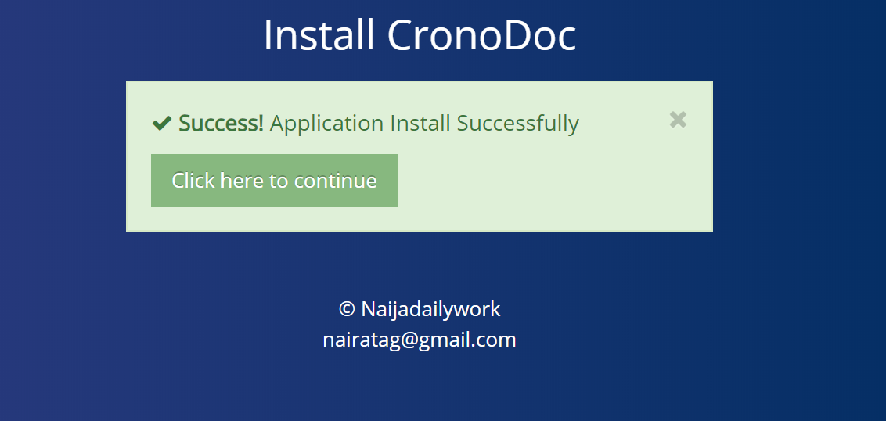
7. **Wait:** Before you click on “Click here to continue”, delete “Install” folder.  
     
   **Super Admin Account**  
   Username: maxillin  
   Password: 123456
8. Click on “Click here to continue. If all goes well, your site should look similar to the picture below:  
   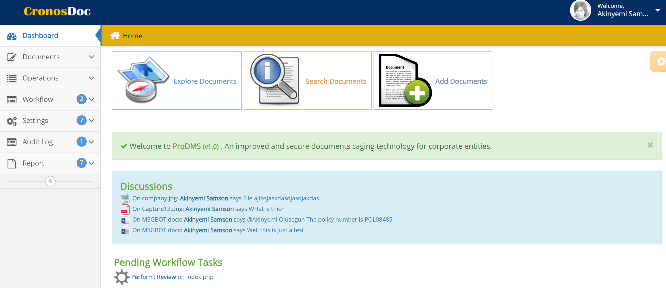

**Few Tips!**

After a successful installation. Click on “General Settings” under Settings menu.  
  
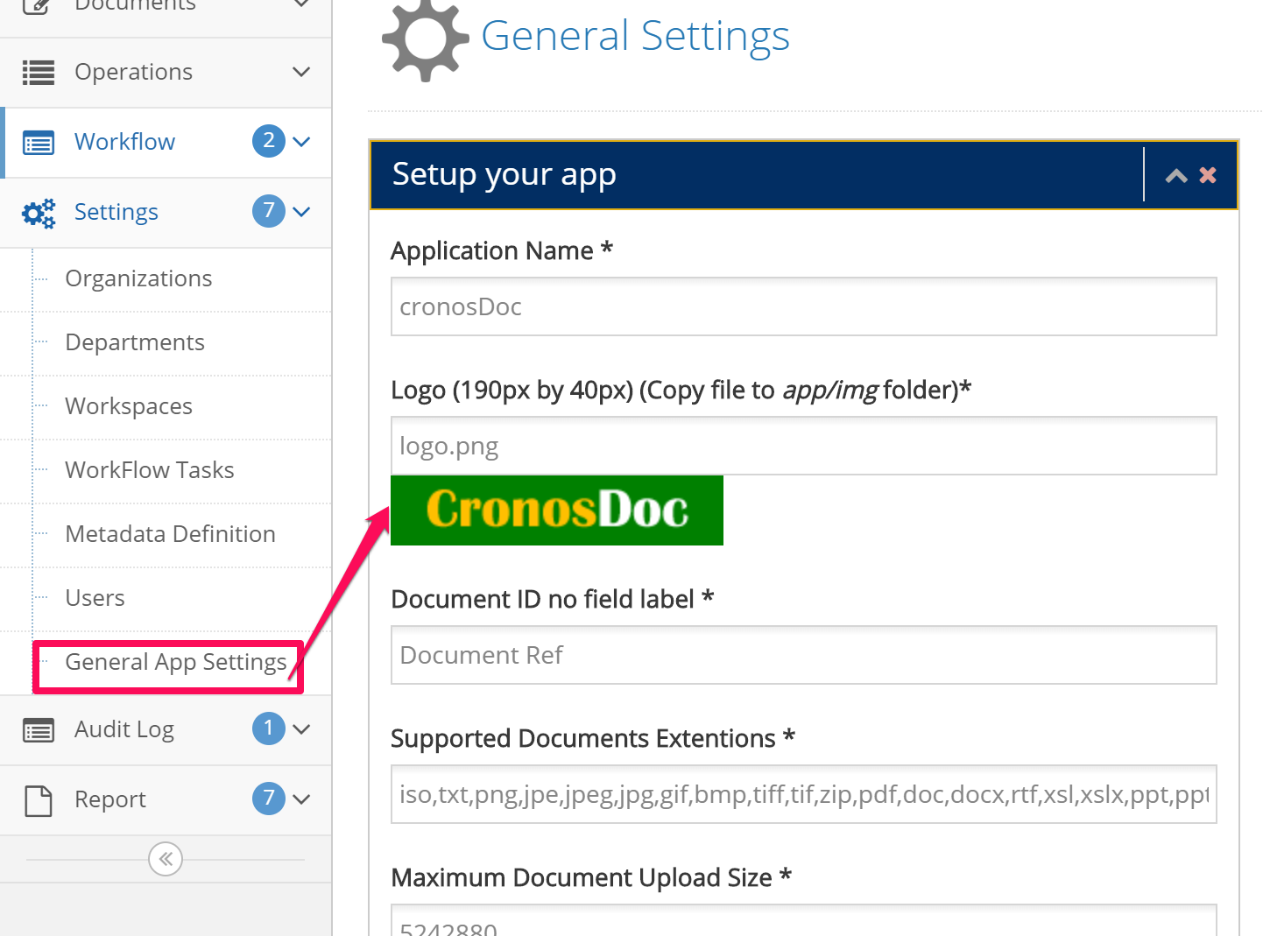  
  
Change all parameters as best suitable for your work environment.

**Drop-Off.**

CronosDoc is capable of connecting to a specified folder and the Document contents for import into CronosDoc File system. The Drop-Off folder must be a readable shared folder on the network.

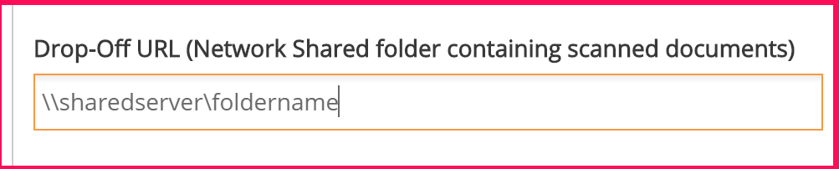

To start using the app, do the following.

* Create your Organization.  
  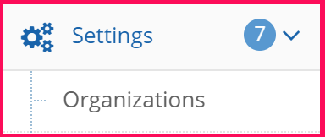
* Create Departments under your Companies.  
  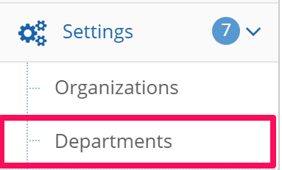
* Create Workspace/Units under individual departments.  
  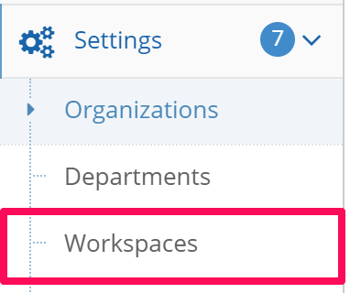
* Create Document Metadata for Indexing  
  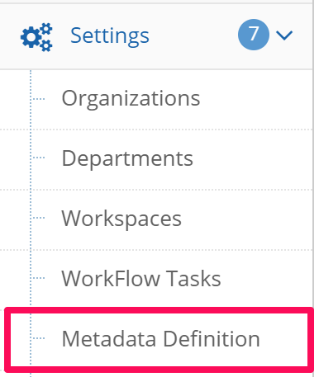  
    
  Add metadata fields.  
  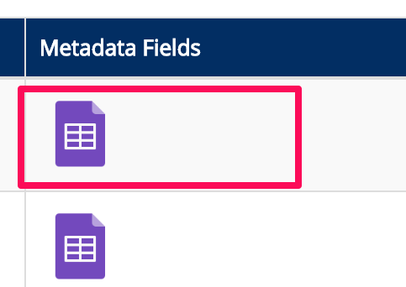
* Create Users  
  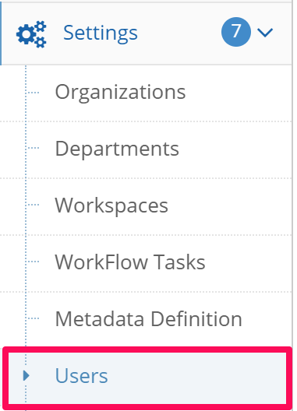
* Create folders and add users to the folder.  
  